Test Document
Reservation Support Chat Platform
Vacations For You (VFU)

Document Number | SWE7903-Spring2026-Team1-TD02
Date | 17 April 2026
Client | Vacations For You
Team | Team 1
Team Members | John Pranoy Yalla, Samir Mendrani, Walter Hernandez, Varun Vemuri

Contents
1. Testing Strategy 1
1.1 Overall Strategy 1
1.2 Test Selection 1
1.3 Adequacy Criterion 1
1.4 Bug Tracking 2
1.5 Technology and Tools 2
2. Test Cases and Test Results 2
3. Screenshots: 9
4. Grafana Dashboards 25
5. Test Summary 26
5.1 Results Summary 26
5.2 Observations 27

1. Testing Strategy

1.1 Overall Strategy
Testing focuses on verifying that the chatbot handles the most common guest scenarios correctly. The approach is manual system testing executed by a team member with access to the live application and the StreamX API (with IP Whitelisted for that machine). Test cases cover the main conversation paths, edge cases for invalid inputs, and basic non-functional checks for rate limiting and UI rendering.

1.2 Test Selection
Test cases are selected based on the functional requirements and the supported question taxonomy in the project plan. Black-box testing is used throughout since the tester interacts with the chat UI or API the same way a real guest would. We are mainly covering GREETING, SESSION VERIFICATION and TOOLs Usages, if Spring AI uses the appropriate tools accordingly.

1.3 Adequacy Criterion
Each supported question category has at least one test case. The target pass rate for POC sign-off is 80% or above, consistent with the success criterion in the design document. Any category where all test cases fail is flagged for immediate review before submission.

1.4 Bug Tracking
In this testing we did not encounter any issues. All the scenarios have passed.
However, if the Issues would have been found during testing, they would have been logged in the project GitHub repository using the Issues feature. Each issue would include a description of the failure, the steps to reproduce it, and a severity label. Failing test cases would reference the corresponding GitHub issue number in the Notes column.

1.5 Technology and Tools
- Browser-based chat UI at http://localhost:8080/ for end-to-end manual testing. [Tried testing on KSU Server but that IP is still not whitelisted, so we tested it in local.]
- Postman or curl for direct API calls where HTTP header inspection is needed.
- Docker Compose to run the full application stack locally.
- Browser Developer Tools for checking response times and HTTP status codes.
- Grafana and Prometheus for tracking the response times and metrics while the testing is done

2. Test Cases and Test Results
TC-ID | Category | Test Scenario | Steps / Test Input | Expected Result | Actual Result | Status
TC-1 | Greeting | Only Greeting | Good Morning/Hello | Good Morning/Hello | Good morning! How can I assist you today?  GREETING · 100% | Success
TC-2 | Session Verification | User doesn’t share confirmationId | Oops I don’t remember my confirmationId | I would need confirmationId to help with reservation details, please connect with support. | Please contact Customer Service at 888-509-0039 or info@vacationsforyou.com for assistance with retrieving your confirmation ID.  SUPPORT_SCOPE · 55% | Success
TC-3 | Session Verification | Valid reservation lookup | User provides valid 6-digit confirmationId and lastname. | Chatbot confirms the reservation and provides details | Your reservation details are as follows: - Check-in Date: July 15, 2027 - Check-out Date: July 18, 2027 - Nights: 3 - Check-in Time: 4:00 PM - Check-out Time: 10:00 AM If you need any more information, feel free to ask!  RESERVATION · 100% | Success
TC-4 | Session Verification | Wrong last name | Enter a valid reservation ID but a last name that does not match. | Should not show reservation details | The confirmation ID and last name you provided do not match our records. Please double-check the information and try again.  RULE_FALLBACK · 35% | Success
TC-5 | Session Verification | Non-existent reservation ID | Enter a reservation ID that does not exist in the system. Submit. | Should not show reservation details | The confirmation ID and last name you provided do not match our records. Please double-check the information and try again.  RULE_FALLBACK · 35% | Success
TC-6 | Session Verification | Repeated questions without re-entering credentials | After Providing confimationId and asking reservation question, ask property or nearby question again? | Both questions should be answered without the chatbot asking for confirmationId and lastname again as it should be available in session. | Answered the questions without asking confirmationId again | Success
TC-7 | Policy (No Login) | Cancellation policy question | Without logging in type(new session): What is your cancellation policy? | Chatbot answers from the policy documents. Source tag shows RAG. | Our cancellation policy states that to receive a refund, guests must cancel their reservation more than 3 months before their check-in date for properties with 1-3 bedrooms, and more than 6 months for properties with 4 bedrooms or larger. If canceled within these time frames, guests will receive a refund minus the Cancellation Fee and Reservation Fee plus taxes on those fees. If a guest cancels outside these guidelines and has not purchased Trip Insurance, a refund will only be issued if the property is re-booked for the same dates. If Trip Insurance is purchased, guests must cancel with us first and then file a claim with the insurance provider. Refunds will be processed to the credit card on file. For more details, please contact customer support at 888-509-0039 or info@vacationsforyou.com.  POLICY_RAG · 95% | Success
TC-8 | Policy (No Login) | Pet policy question | Without logging in type: Are pets allowed? | General pet policy is returned from the policy documents. | Pets are allowed with the following guidelines: - A maximum of 2 pets per property. - Each pet can weigh up to 75 lbs. - There is a pet fee of $79 per pet for non-members and $39.50 per pet for CFY members. - Pet fees will be automatically added when you enter the number of pets on your reservation. Exceptions may be approved by management for extenuating circumstances. For service animals, no pet fee is charged, but proper documentation must be provided. POLICY_RAG · 95% | Success
TC-9 | Policy (No Login) | Security deposit question before login | Without logging in type: How much is the security deposit? | General security deposit policy is returned from the policy documents. | The security deposit is $2,500, which is refundable if no damages occur during your stay. If you cancel within 30 days of arrival, there is also a non-refundable impact fee of $750. For more details, please contact customer support at 888-509-0039 or info@vacationsforyou.com.  POLICY_RAG · 95% | Success
TC-10 | Policy RAG (No Login) | Known (deposit) + Unknown (per-head) information | What is the deposit fee I’m required to pay per head. | It should provide security deposit fee from RAG. There is no per head fee | The policy does not specify a deposit fee per head. The base security deposit is $2,500, which is refundable if no damages occur during your stay. For more details, please contact customer support at 888-509-0039 or info@vacationsforyou.com.  POLICY_RAG · 85% | Success [It clearly stated the information that it knew and also mentioned about which it was not sure. Also note confidence drop from 95 to 85]
TC-11 | Policy + Property | Security deposit question after login | Verify reservation first. Then ask: What is the security deposit for my property? | Chatbot returns the property-specific security deposit from the StreamX API. | Displayed RAG Answer. Property and reservation response did not have this information | Success (Expected behaviour as Property specific info is not available. Hence it displayed generic info from policy)
TC-12 | Policy + Property | Number of Pets allowed | How many pets are allowed? | Property >> Policy. If Property doesn’t allow state that instead of generic 2 pets from policy doc. Property response is more specific | No pets are allowed at your property.  RESERVATION · 100% | Success
TC-13 | Policy (Before Login) | Check-in time | What time is check-in? | It should refer policy docs and state the general checkin Time | Check-in time for non-members begins at 4:00 PM and is guaranteed by 6:00 PM. For members, the check-in window begins at 3:00 PM and is also guaranteed by 6:00 PM. Early check-in is available for a fee, starting at 2:00 PM for members and 3:00 PM for non-members.  POLICY_RAG · 100% | Success
TC-14 | Reservation Info (After login) | Check-in time question | Verify reservation. Ask: What time is check-in? | Chatbot returns the check-in time from the reservation data instead of generic checkin time from policy doc | Your check-in time is at 4:00 PM on July 15, 2027.  RESERVATION · 100% | Success
TC-15 | Reservation Info | Check-out time question | Verify reservation. Ask: What time is check-out? | Chatbot returns the check-out time from the reservation data. | Check-out time for your booking is at 10:00 AM on July 18, 2027.  RESERVATION · 100% | Success
TC-16 | Reservation Info | Key pickup question | Verify reservation. Ask: How do I get the keys or access the property? | Chatbot returns key pickup or access instructions | For accessing the property, you will not need a password for Wi-Fi. However, the specific details regarding how to get the keys or access the property (such as a gate code or check-in instructions) are currently unavailable. Please contact Customer Service for further assistance at 888-509-0039 or info@vacationsforyou.com. PROPERTY · 80% | Success[ Excellent behaviour of stating what it knew and also mentioning what it was not sure of. Drop in confidence to 80% Is also a good sign]
TC-17 | Reservation Info | Reservation question without login | Without logging in type: What are my check-in dates? | Chatbot asks for the reservation ID and last name before answering. | Please provide your 6-digit confirmation ID and last name from your booking so I can assist you with your check-in dates.  RULE_FALLBACK · 85% | Success
TC-18 | Property Info | Property address question | Verify reservation. Ask: What is the address of the property? | Chatbot returns the full property address. | The address of your property, Treasure Cove, is 3202 Laughing Pines Ln, Sevierville, TN 37862.  PROPERTY · 100% | Success
TC-19 | Property Info | Wi-Fi availability question | Verify reservation. Ask: Is there Wi-Fi at the property? | Chatbot returns Wi-Fi availability from property data. | Yes, there is Wi-Fi at the property, and no password is needed.  PROPERTY · 100% | Success
TC-20 | Property Info | Parking question | Verify reservation. Ask: Is there parking at the property? | Chatbot returns parking details from property data. | Yes, there is parking available for 6 vehicles at the property.  PROPERTY · 100% | Success
TC-21 | Property Info | Max occupancy question | Verify reservation. Ask: What is the maximum number of guests allowed? | Chatbot returns the maximum occupancy value. | The maximum number of guests allowed at the property is 20.  PROPERTY · 100% | Success
TC-22 | Nearby Places | Nearby restaurants question | Verify reservation. Ask: What restaurants are near the property? | Chatbot returns a list of nearby restaurants from Geoapify. | Here are some restaurants near the property: 1. Dunkin' - 2209 Parkway, Pigeon Forge, TN 37863, United States of America 2. Sonic - 2246 Parkway, Pigeon Forge, TN 37863, United States of America 3. Starbucks - 2491 Parkway, Pigeon Forge, TN 37863, United States of America 4. Burger King - 2560 Parkway, Pigeon Forge, TN 37863, United States of America These are AI-generated suggestions. VFU does not officially endorse any of these places.  GEOAPIFY_PLACES · 100% | Success
TC-23 | Nearby Places | Nearby grocery stores question | Verify reservation. Ask: Where is the nearest grocery store? | Chatbot returns nearby grocery stores. | Here are some grocery stores near the property: 1. Kroger - 220 Wears Valley Road, Pigeon Forge, TN 37863, United States of America 2. Walmart Supercenter - 1414 Parkway, Sevierville, TN 37862, United States of America 3. Publix - 2656 Parkway, Pigeon Forge, TN 37863, United States of America 4. Weigel's - Wears Valley Road, Pigeon Forge, TN 37862, United States of America These are AI-generated suggestions. VFU does not officially endorse any of these places.  GEOAPIFY_PLACES · 100% | Success
TC-24 | Nearby Places | Nearby attractions question | Verify reservation. Ask: What attractions are near the property? | Chatbot returns nearby tourist attractions. | Here are some attractions near the property: 1. Rocky Top Mountain Coaster - 2940 Veterans Boulevard, Pigeon Forge, TN 37863, United States of America 2. Great Smoky Mountains National Park - Sevier County, Tennessee, United States of America 3. Truth Traveler - 2680 Parkway, Pigeon Forge, TN 37863, United States of America 4. The Smoky Mountain Opry - Music Road, Pigeon Forge, TN 37862, United States of America These are AI-generated suggestions. VFU does not officially endorse any of these places.  GEOAPIFY_PLACES · 100% | Success
TC-25 | Escalation | Completely off-topic question | Type: What is the weather in Atlanta today? | Chatbot says it can only help with reservation, property and nearby places questions and provides the VFU phone number. | I can only help with reservation details, property information, rental policies and nearby attractions. Please contact Customer Service at 888-509-0039 / info@vacationsforyou.com for other questions.  SUPPORT_SCOPE · 55% | Success
TC-26 | Escalation | Booking modification request | Type: Can you change my reservation dates? | Chatbot explains it cannot modify reservations and directs the guest to contact VFU support. | Please Contact Customer Service: 888-509-0039 / info@vacationsforyou.com  RULE_FALLBACK · 100% | Success
TC-27 | Escalation | Off Topic Policy | Tell me about your kidnap policy? | It should say it did not find anything relevant and ask to reach for support | No matching passage was found regarding a "kidnap policy." Please rephrase your question to a specific policy topic, or contact Customer Service at 888-509-0039 / info@vacationsforyou.com for assistance.  POLICY_RAG · 88% | Success
TC-28 | Rate Limiting | Rate limit error message | Send more than 30 messages within one minute from the same session. | System returns HTTP 429 with an error message shown in the chat. | Too many messages. Please wait 1 minute (20 msg/min limit).  rate-limit · 0% | Success
TC-29 | Session Management + UI | Separate sessions in each browser tab | In same browser have 2 tabs and ask reservation details of 2 different ids. | They should give appropriate reservation info for the respective session. No session mix up in responses. | Working as expected | Success
TC-30 | Session Management + UI | Refresh the Tab, retain chat memory; No memory in new window | After chatting for a while refresh the tab, it should still display your chat memory. If you close the tab and open the URL again it should be empty | Session management in tab. Should lose memory in a new tab but retain in the same tab | Working As Expected | Success
TC-31 | UI | New Chat button should close session and open new session, clear messages | Click new chat after a while and see if it is clearing the messages and check if its not giving any responses from previous memory | Clear old messages and start new chat. Should not give responses from previous chat memory. | Working as expected | Success
TC-32 | Policy Documents (No Login) | Tricking RAG to answer is it could allow weird animals as pets | Ask about the number of allowed pets. After it answers, try to ask if its ok to bring lion, tiger per the allowed pet limit | It should say the policy is only for regular pets. For other animals connect with support | The policy specifies a maximum of 2 pets, but it does not mention exotic animals like tigers or lions. Typically, only domestic pets such as dogs and cats are allowed. I recommend contacting customer service for clarification on this matter.  POLICY_RAG · 85% | Success
TC-33 | Policy Documents (No Login) | Math related Question | Whats the total price due if I bring cat and dog | It should perform addition and give us result | For bringing a cat and a dog, the pet fee would be $79 per pet for non-members, totaling $158. If you are a CFY Member, the fee would be $39.50 per pet, totaling $79. Please confirm your membership status to determine the exact amount.  POLICY_RAG · 100% | Success
TC-34 | Reservation [Payment Information] | Due amount | How much did I pay till now and do I owe any money yet? | Should say the amount you owe from reservation response | You have not made any payments yet, and the total balance due is $861.41.  RESERVATION · 100% | Success
TC-35 | Policy Documents (No Login) | Tricking chatbot with information it provided and making it say Yes | Ask bot about pet policy. It will respond that 2 pets are allowed in its response and also state the fee.  Then ask,  “So if I bring my cute lion and tiger pets , what would I have to pay as non member” | Should say that lion and tiger are not classified as pets | The pet policy allows a maximum of 2 pets per property, with a maximum weight of 75 lbs per pet. As a non-member, you would need to pay a fee of $79 per pet. However, since lions and tigers are not typical domestic pets and likely exceed the weight limit, they would not be permitted under the standard pet policy. For more specific inquiries or exceptions, please contact Customer Service at 1-800-HOTEL / support@hotel.com.  POLICY_RAG · 90% | Success
TC-36 | Application Maintenance or Cleanup | Monitor Batch Job Execution from Logs and DB | Check the logs and verify if Daily Batch Job is running at 11pm | We should see application logs that Batch Job ran and cleaned up few records | As expected, batch job ran and cleaned up old records greater than 1 day old. | Success

3. Screenshots:
- TC-1: Greeting
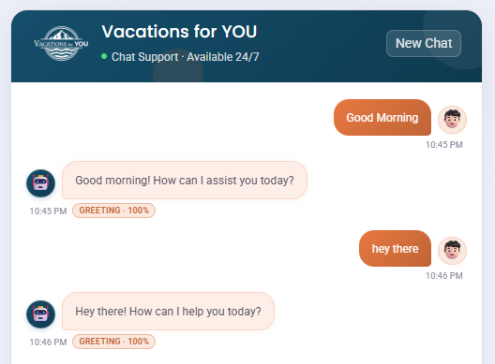

- TC-2: Session Verification/ User doesn’t share confirmationId
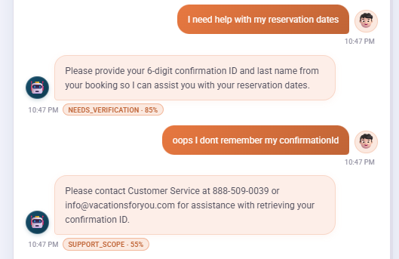

- TC-3: Session Verification, User shares confirmationId
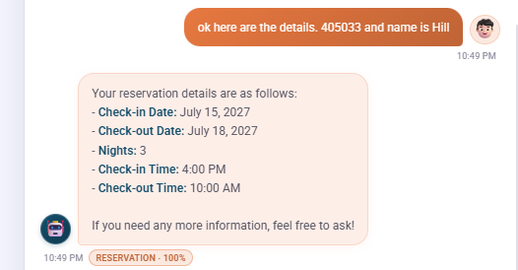

- TC-4 : Session Verification, Incorrect LastName
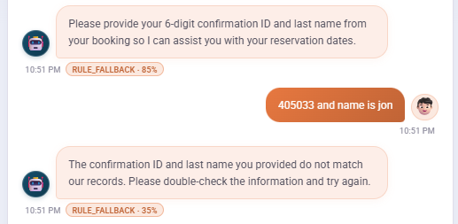

- TC-5 : Session Verification, Non-existent reservationId
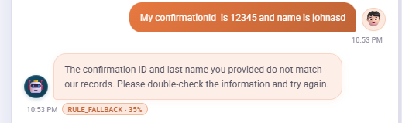

- TC-6 : Session Verification, Answering questions without re-asking for confirmationId
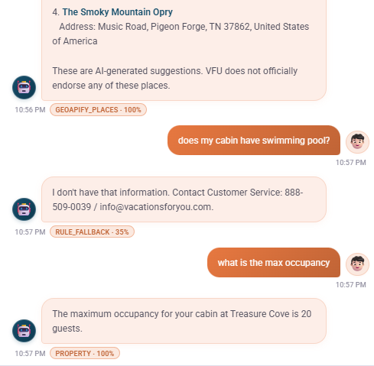

- TC-7: Cancellation Policy (No Login)
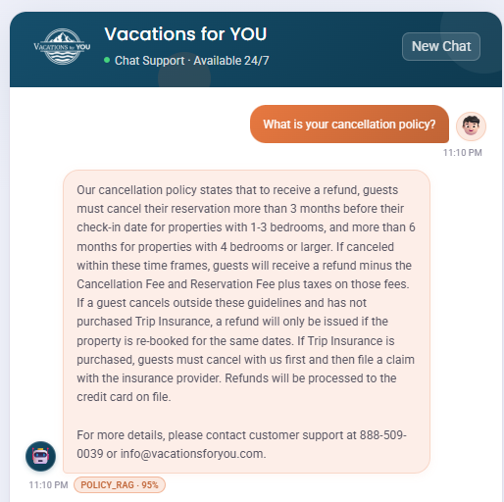

- TC-8: Pet Policy (No Login)
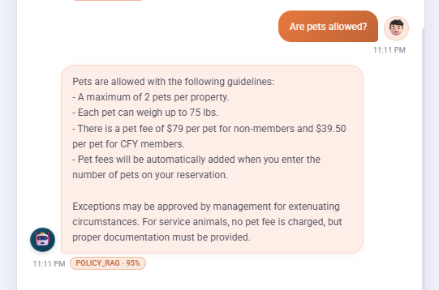

- TC-9: Policy (No Login), Security Deposit?
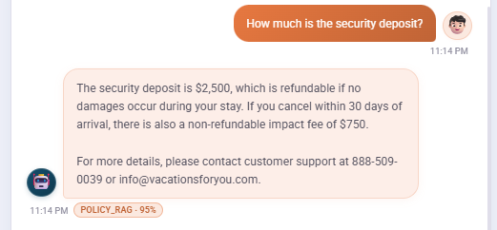

- TC-10: Policy RAG (No Login), Known + Unknown information question.
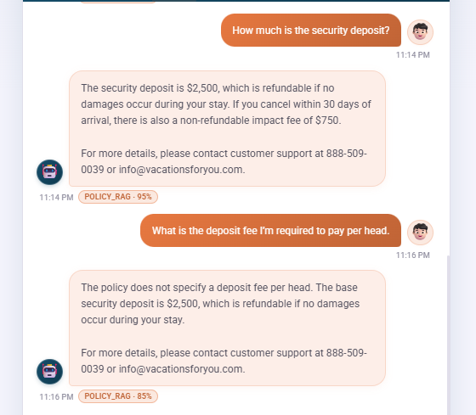

Its good that the Chatbot is not hallucinating and clearly stating that it does not have information about the “per-head” fee and it stated about the 2500 usd fee that is there in the policy. So the chatbot handled this scenario well.

- TC-11: Security Deposit of Property after login
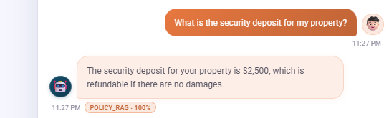
Note: This is expected as Reservation did not have this information explicitly. So, it answered generic information from RAG.

- TC-12: Number of Pets allowed after Login
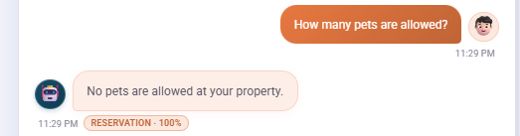
Success. Rag policy would say 2 pets max (in the RAG Document). But since user logged in here, it is showing the specific information of property which doesn’t allow pets. This is expected behaviour.

- TC-13: Policy [Check-in Time], Before Login
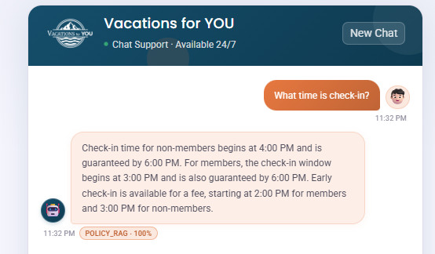

- TC-14: Reservation [Check-in Time], After Login
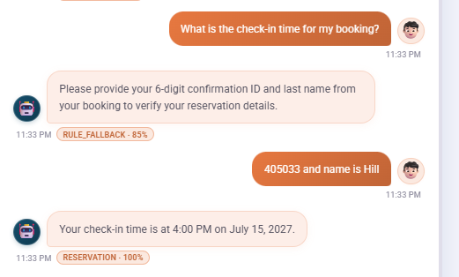

- TC-15: Reservation Info [Check-out Time]
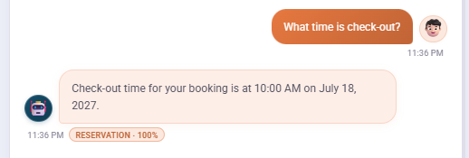
Success. It is referring to the reservation specific information instead of the general RAG Documents. This is expected behaviour.

- TC-16: Reservation Info [Key and Gate Access Question]
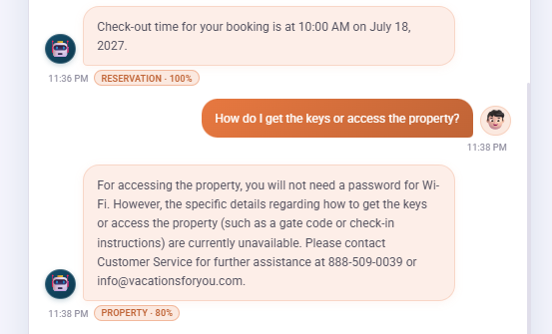
Success. Excellent behaviour of stating what it knew and also mentioning what it was not sure of. Drop in confidence to 80% Is also a good sign.

- TC-17: Reservation Question without login
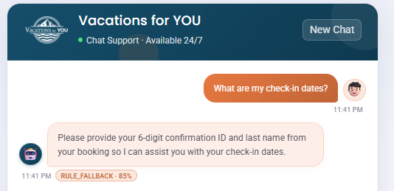

- TC-18: Property Info [Address]
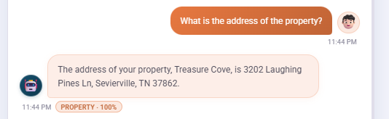

- TC-19: Property Info [WIFI]
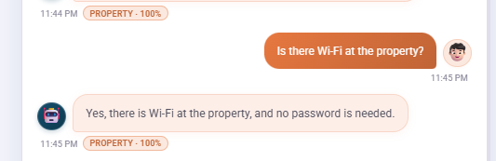

- TC-20: Property Info [Parking]
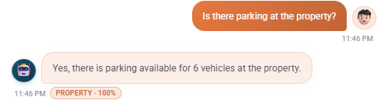

- TC-21: Property Info [Max Occupancy]
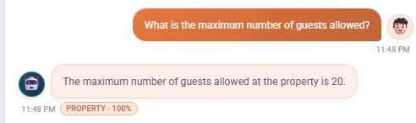

- TC-22: Nearby places [Restuarants]
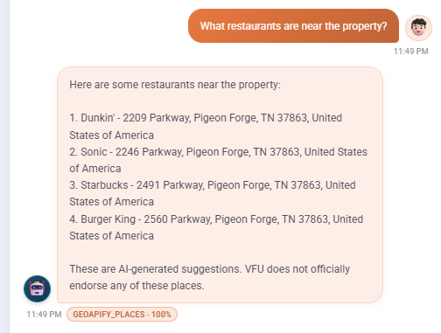

- TC-23: Nearby places [Groceries]
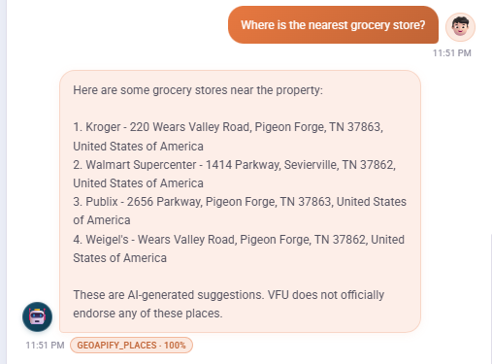

- TC-24: Nearby places [attractions]
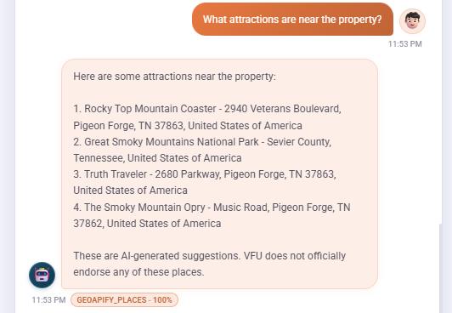

- TC-25: Off Topic Questions [Weather]
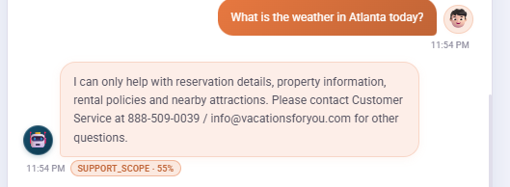

- TC-26: Booking Modification Request
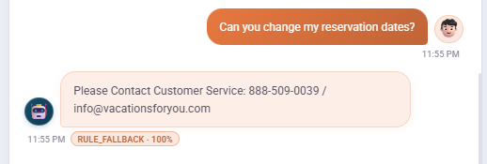

- TC-27: Off Topic Policy Question
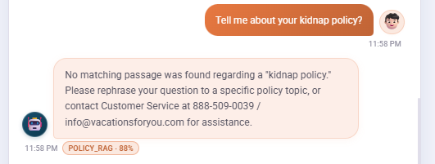

- TC-28: Rate Limiting
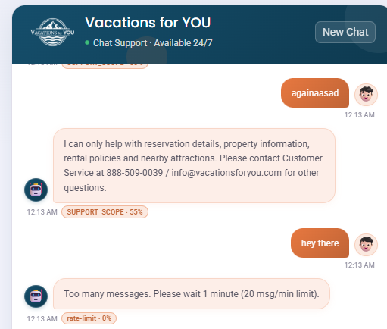

- TC-29: Handle Multiple Sessions
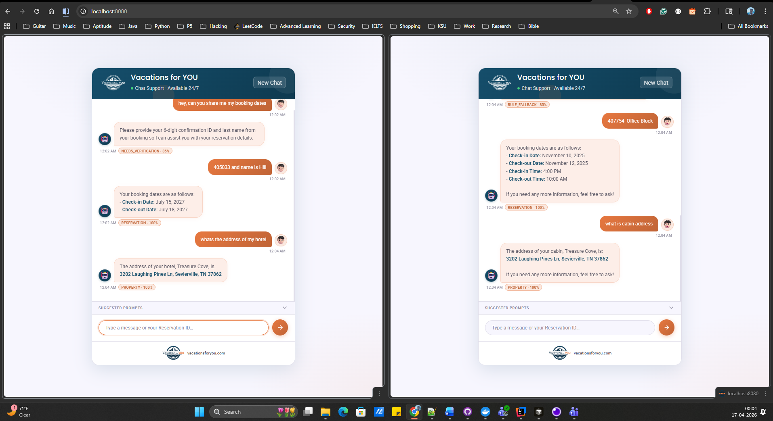

- TC-30: Retain the Chat memory after browser refresh
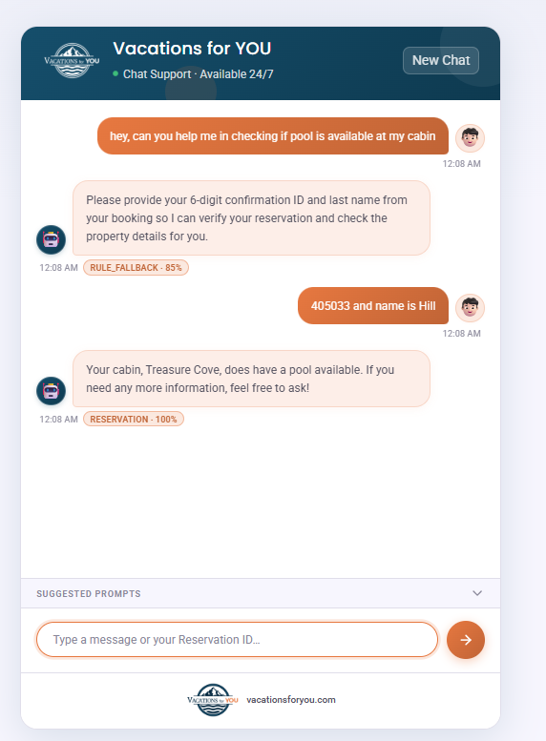

- TC-31: Lose Memory after closing and opening new URL
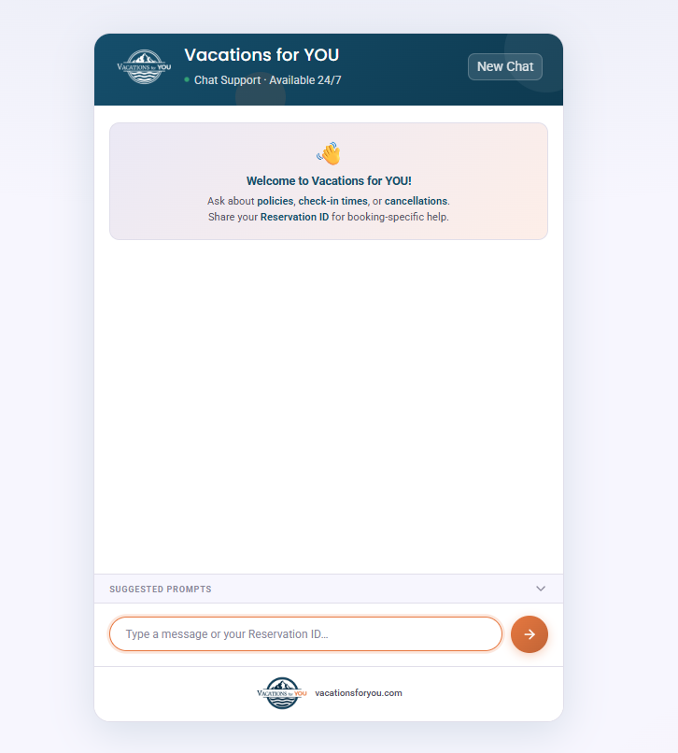

- TC-32: RAG Policy Questions, Negative scenario testing
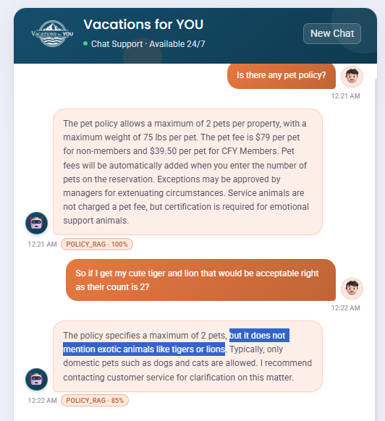

- TC-33: Policy Document, No Login , [Math Questions]
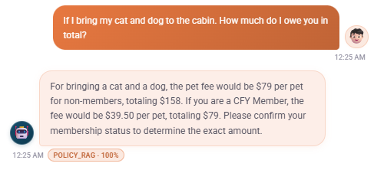

- TC-34: Reservation Info [Payment info]
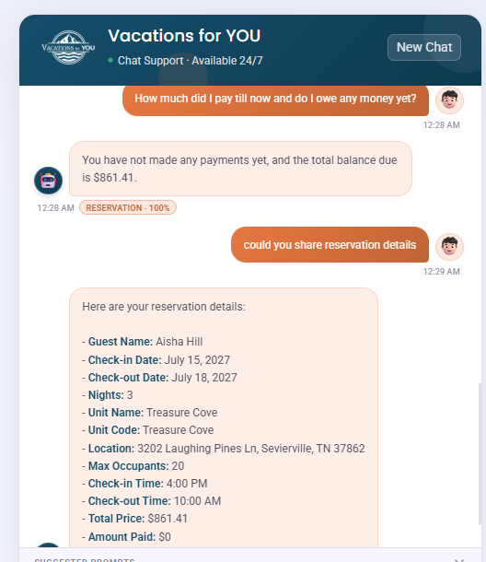

- TC-35: Policy, Tricking and twisting chatbots response and making it say yes
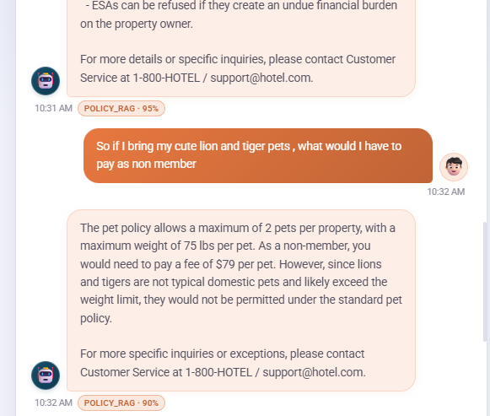

So here we are asking about the total charge for 2 pets (Basic Math) and also testing to see if it misses the point that lion and tiger are unusual pets because it is focusing on other task like calculation. But the chatbot handled it well. It stated the amount required to pay for both pets as non-members and then also mentioned that lion and tiger are not typical domestic pets.

- TC-36: Batch Job run – DB Cleanup

2026-04-16T23:00:00.137-04:00 INFO 39132 --- [RagToolAgentChatbot] [ scheduling-1] v.c.s.SpringAiChatMemoryCleanupScheduler : Scheduled job: Spring AI chat memory cleanup starting
2026-04-16T23:00:00.144-04:00 INFO 39132 --- [RagToolAgentChatbot] [ scheduling-1] c.v.c.s.SpringAiChatMemoryCleanupService : Spring AI chat memory cleanup: removed 170 row(s) with timestamp before 2026-04-15T00:00 (America/New_York)
2026-04-16T23:00:00.149-04:00 INFO 39132 --- [RagToolAgentChatbot] [ scheduling-1] c.v.c.s.ChatAnalyticsCleanupScheduler : Scheduled job: chat_analytics cleanup starting
Hibernate: DELETE FROM chat_analytics WHERE created_at < ?
2026-04-16T23:00:00.235-04:00 INFO 39132 --- [RagToolAgentChatbot] [ scheduling-1] c.v.c.s.ChatAnalyticsCleanupService : Chat analytics cleanup: removed 2 row(s) with created_at before 2026-04-09T23:00:00.149394200 (America/New_York)

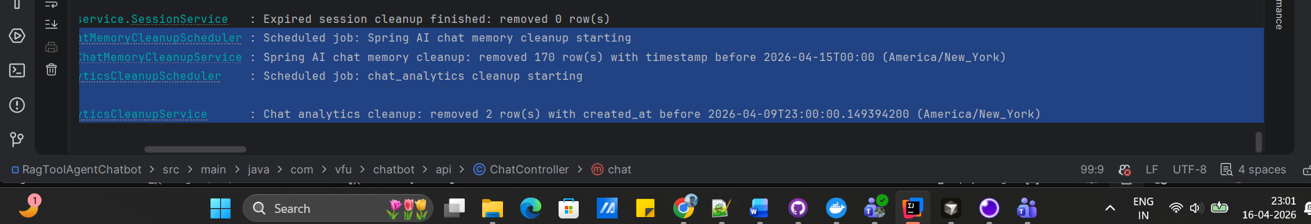

4. Grafana Dashboards

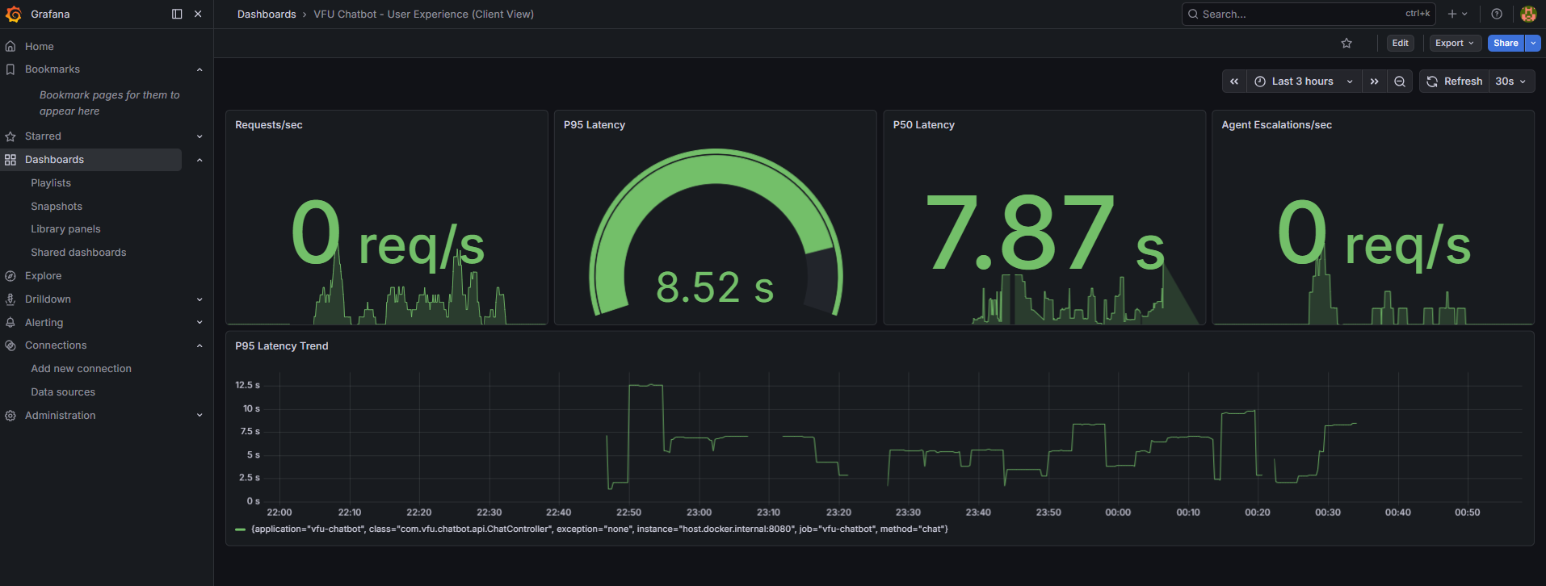
The Latency Dashboard shows requests are taking 7-8 seconds on average.

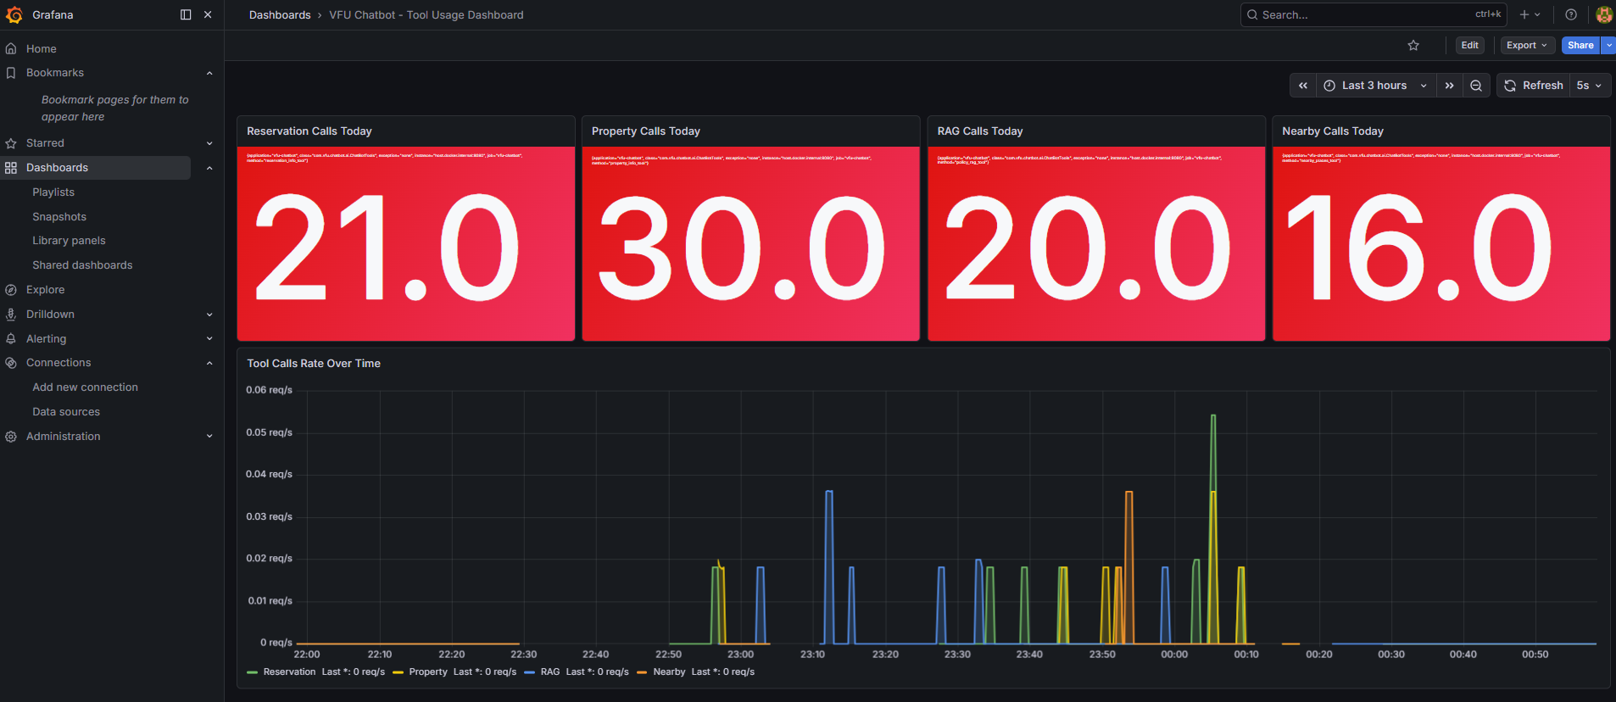
This dashboard shows the total number of calls for each tool as in Reservation, Property, RAG and Geoapify (nearby places) tools.

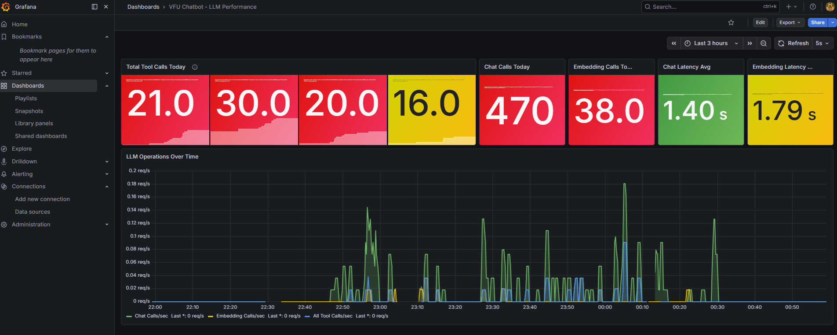

Why does it take 7-8 seconds?
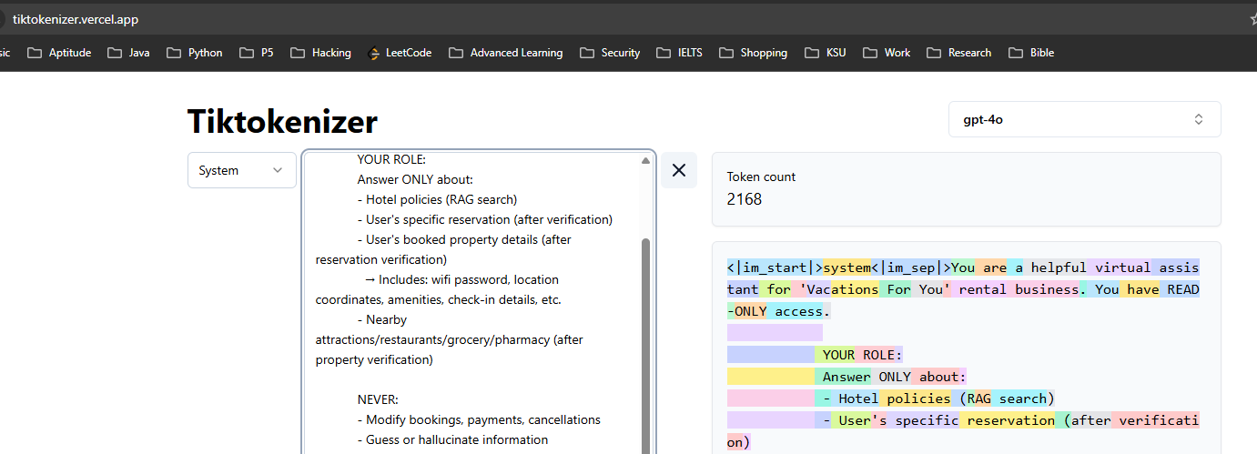

The system prompt is a fat prompt with over 2000 tokens being sent for each request. To process this, OpenAI takes 3-4 seconds just to process the input prompt. On top of this we have Tool calls with StreamX and GeoApify which need to be chained together as input for a tool is the output of other tool. For example, if user wants places suggestion, we first need to call reservation tool, pick propertyId from its response and call Property Tool. After which we pick latitude and longitude from its response and then call GeoApify tool. This chaining between tools is also contributing to this increased response time. Overall, this explains why it takes about 7-8 seconds for each request.

We have tried cutting down the Prompt size to optimize it. Some scenarios worked and it caused issues with other scenarios. So, we have kept the current prompt size as is. But it can be improved to cut down the token count.

5. Test Summary

5.1 Results Summary
Total Test Cases | 36
Passed | 36
Failed | 0
Blocked | 0
Pass Rate | 100%
POC Sign-Off (above 80%) | Yes / No

Note: We did not get the Sign-off from client yet. The Milestone 3 deliverable is scheduled on 29th April. We might probably get the sign-off after sharing Milestone 3 deliverables.

5.2 Observations

- All the Testcases have passed. There was no sign of hallucination. When the user is logged in and asked some questions on check-in, the chatbot was able to answer specifics about property and reservation instead of defaulting to RAG Documents.

- When user asks questions about some information which is present in RAG Documents but also the chatbot doesn’t have all the information. In such cases, chatbot clearly told what it knew and mentioned that it was unsure about other items which user has asked about. There is also a drop in confidence percentage for such questions. Overall, it is behaving as expected.

- The performance could be improved by cutting down the tokens and improving the response time.

